Deep Learning
2. Training, Optimization and Regularization of Deep Neural Network
2.1 Training Feedforward DNN
Multi Layered Feed Forward Neural Network, Learning Factors, Activation functions: Tanh, Logistic, Linear, Softmax, ReLU, Leaky ReLU, Loss functions: Squared Error loss, Cross Entropy, Choosing output function and loss function
2.2 Optimization
Learning with backpropagation, Learning Parameters: Gradient Descent (GD), Stochastic and Mini Batch GD, Momentum Based GD, Nesterov Accelerated GD, AdaGrad, Adam, RMSProp 2.3 Regularization
Overview of Overfitting, Types of biases, Bias Variance Tradeoff Regularization Methods: L1, L2 regularization, Parameter sharing, Dropout, Weight Decay, Batch normalization, Early stopping, Data Augmentation, Adding noise to input and output
PAST QUESTIONS:
- Suppose we have N input-output pairs. Our goal is to find the parameters that predict the output y from the input x according to some function y= x w . Calculate the sum-of squared error function E between predictions y and inputs x. The parameter w can be determined iteratively using gradient descent. For the calculated error function E, derive the gradient descent update rule w←w-α dE/dw. (D23)
- Explain dropout. How does it solve the problem of overfitting? (D23)
- What is an activation function? Describe any four activation functions. (D23)
- Explain early stopping, batch normalization, and data augmentation. (D23)
- Explain Stochastic Gradient Descent and momentum based gradient descent optimization techniques. (D23)
- Explain the dropout method and it’s advantages. (M24, D24)
- What are the different types of Gradient Descent methods, explain any three of them. (M24, D24)
- What are L1 and L2 regularization methods? (M24)
- What is the significance of Activation Functions in Neural Networks, explain different types Activation functions used in NN. (M24)
- Comment on the significance of Loss functions and explain different types of Loss functions while training a network. (D24)
- What is the significance of Activation Functions in Neural Networks, explain different types of Activation functions used in NN. (D24, M25)
- Explain regularization in neural network. (M25)
- Explain the gradient descent algorithm used in neural network. Also discuss types of gradient descent in detail. (M25)
- Discuss the role of a loss function in training a neural network. Compare Mean Squared Error (MSE) and Cross-Entropy Loss in terms of their usage, characteristics, and impact on model performance. In which scenarios would using Cross-Entropy Loss be more appropriate than MSE? Justify your answer with a suitable example. (M25)
- Explain the learning process in a neural network. How does a neural network update its weights during training? Describe the role of forward propagation, loss calculation, backpropagation, and optimization in this learning process. (M25)

NOTES:

*Activation Functions :-
An Activation Function is a mathematical operation applied to the output of each neuron in a neural network.
Activation functions decide whether a neuron should be activated or not, based on the weighted sum of inputs and a bias term.
Activation functions introduce non-linearity, which allows neural networks to learn and model complex patterns in data.
Without activation functions, a neural network would behave like a linear model, no matter how many layers it has.
This means it could only learn linear relationships.
By introducing non-linear activation functions, the network becomes capable of learning non-linear and intricate mappings between inputs and outputs — which is essential for tasks like image recognition, speech processing, and natural language understanding.
Activation function introduces non linearity, helps prevent vanishing or exploding gradient during backpropagation, controls the output range, improve models learning efficiency.
Functions -
- Linear: Linear Activation Function resembles straight line define by y=x. No matter how many layers the neural network contains if they all use linear activation functions the output is a linear combination of the input.
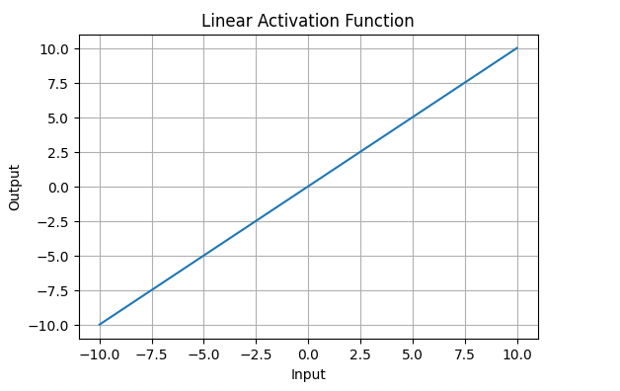
Linear activation functions are useful for specific tasks but must be combined with non-linear functions to enhance the neural network’s learning and predictive capabilities.

- Sigmoid: Sigmoid is a mathematical function that maps any real-valued number into a value between 0 and 1. It is used for modelling binary classification problems, smoothing outputs, and introducing non-linearity into models.
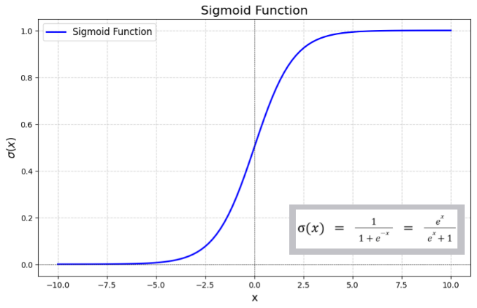

- Tanh: Tanh function(hyperbolic tangent function) is a shifted version of the sigmoid, allowing it to stretch across the y-axis. It is defined as:
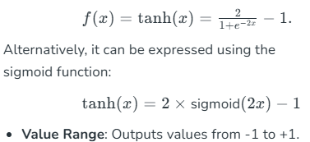
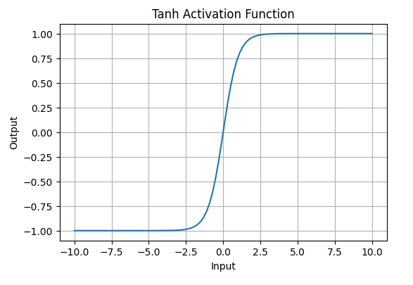

- ReLU: Rectified Linear Unit (ReLU) allows positive values to pass through unchanged while setting all negative values to zero.
Mathematically represented as:
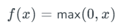
ReLU activation is defined by $A(x)=max⁡(0,x)$, this means that if the input x is positive, ReLU returns x, if the input is negative, it returns 0.
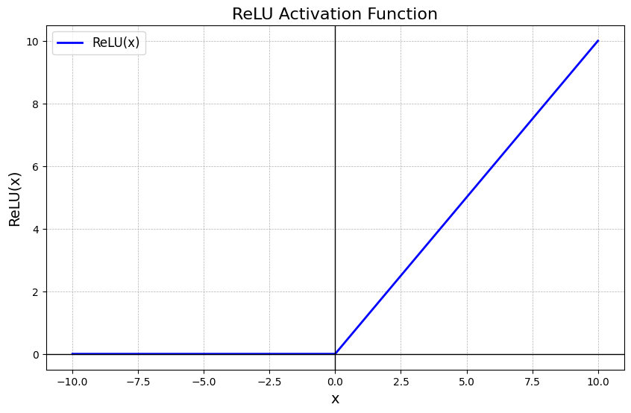
- Leaky ReLU: Leaky ReLU is similar to ReLU but allows a small negative slope ($α$, e.g., 0.01) instead of zero. Solves the “dying ReLU” problem, where neurons get stuck with zero outputs.
Range: $(-∞,∞)$.
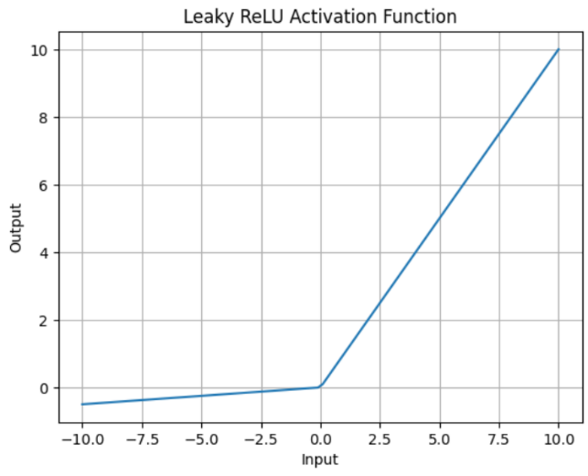

- Softmax: Softmax function is a mathematical function that converts a vector of raw prediction scores (often called logits) from the neural network into probabilities. These probabilities are distributed across different classes such that their sum equals 1. 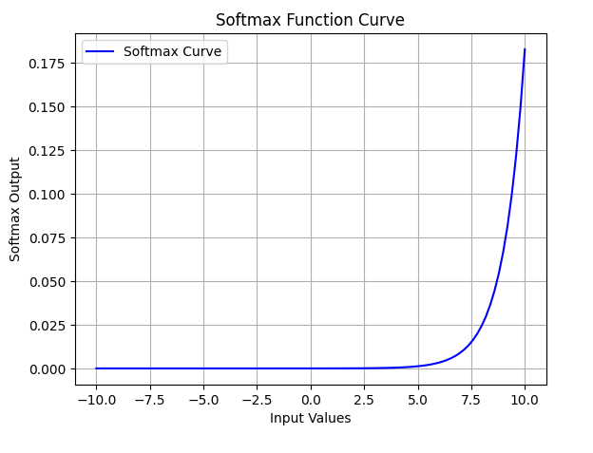

*Loss Function :-
A Loss Function (also called a Cost Function) is a mathematical function that measures how well a neural network’s predictions match the actual target values.
It computes the difference between the predicted output and the true output, and this value guides the optimization process during training.
In simple terms, the loss function tells the network how wrong it is — the smaller the loss, the better the model’s performance.
The loss function plays a crucial role in training neural networks:
- Guides Learning: It provides feedback to the network about prediction errors.
- Controls Weight Updates: During backpropagation, the loss is used to calculate gradients that update network weights.
- Ensures Convergence: The optimizer minimizes the loss function to achieve the best possible model performance.

- Measures Performance: It quantifies the accuracy and reliability of the model’s predictions.
Types of Loss Functions –
1. Mean Squared Error: Mean Squared Error (MSE) Loss is one of the most widely used loss functions for regression tasks. It calculates the average of the squared differences between the predicted values and the actual values. It is simple to understand and sensitive to outliers because the errors are squared which can affect the loss.
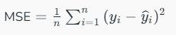

2. Cross Entropy: Binary Cross-Entropy Loss is also known as Log Loss and is used for binary classification problems. It measures the performance of a classification model whose output is a probability value between 0 and 1.
Cross-Entropy measures the difference between two probability distributions —
- the true labels (actual values), and
- the predicted probabilities from the model.
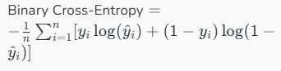

*Gradient descent types :-
Batch GD: Batch Gradient Descent computes the gradient of the cost function using the entire training dataset for each iteration. This approach ensures that the computed gradient is precise, but it can be computationally expensive when dealing with very large datasets.
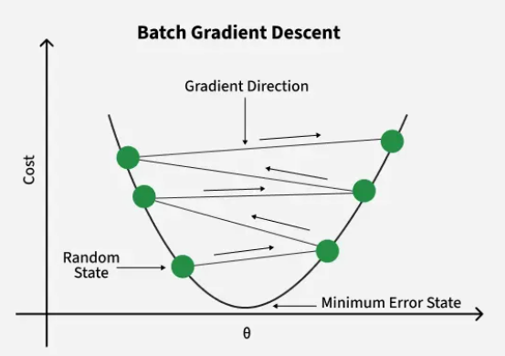

Stochastic: Stochastic Gradient Descent (SGD) addresses the inefficiencies of Batch Gradient Descent by computing the gradient using only a single training example (or a small subset) in each iteration. This makes the algorithm much faster since only a small fraction of the data is processed at each step.
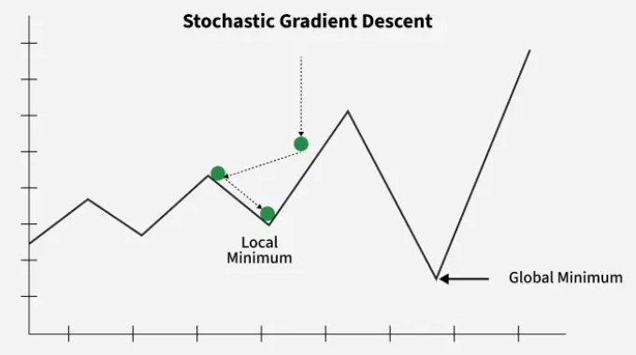

Mini Batch GD: Mini-Batch Gradient Descent is a compromise between Batch Gradient Descent and Stochastic Gradient Descent. Instead of using the entire dataset or a single training example Mini-Batch Gradient Descent updates the model parameters using a small, random subset of the training data called a mini-batch.
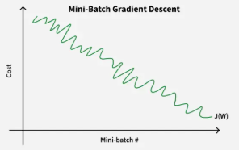

Momentum Based GD: Momentum-Based Gradient Descent is an enhancement of standard gradient descent algorithm that aims to accelerate convergence particularly in the presence of high curvature, small but consistent gradients or noisy gradients. It introduces a velocity term that accumulates the gradient of the loss function over time thereby smoothing the path taken by the parameters.
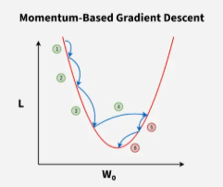

*Regularization :-
L1 and L2 regularization are techniques used in deep learning to prevent overfitting by adding a penalty term to the loss function based on the model's weights.

L1: Lasso Regression (Least Absolute Shrinkage and Selection Operator) adds “Absolute value of magnitude” of coefficient, as penalty term to the loss function.
Lasso shrinks the less important feature’s coefficient to zero; thus, removing some feature altogether. So, this works well for feature selection in case we have a huge number of features.

L2: Adds a penalty term equal to the sum of the squares of the weights to the loss function. Also known as weight decay.

Dropout: Dropout involves dropping neurons in the hidden layers and (optionally) the input layer. It involves randomly setting a fraction of input units to zero at each update during training, which helps prevent overfitting. During training, each neuron is assigned a “dropout” probability, like 0.5.
With a dropout of 0.5, there’s a 50% chance of each neuron participating in training within each training batch. This results in a slightly different network architecture for each batch. It is equivalent to training different neural networks on different subsets of the training data.
Prevents co-dependency among neurons and improves generalization.
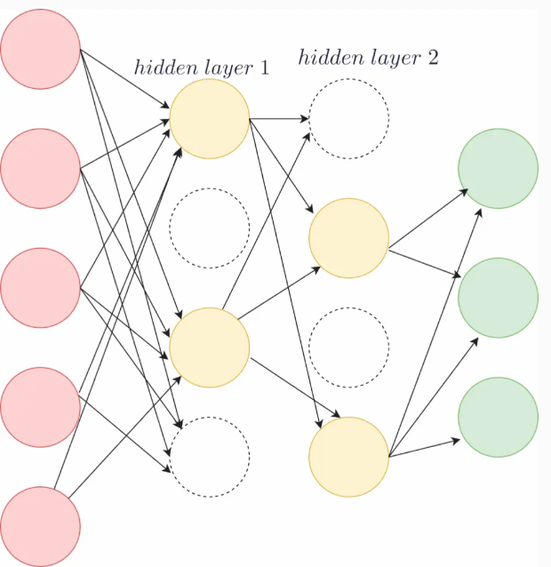

Weight Decay: Weight decay, also known as L2 regularization, is a method used to penalize large weights in the model. It involves adding a term to the loss function proportional to the sum of the squared weights.

Batch normalization: Batch normalization is a deep learning technique that normalizes the inputs to a layer in a neural network, improving training speed and stability by addressing the issue of internal covariate shift. It works by standardizing the activations of each mini-batch to have a mean of zero and a standard deviation of one.

Early stopping: Early stopping is one of the simplest and most intuitive regularization techniques. It involves stopping the training of the neural network at an earlier epoch; hence the name early stopping.
As you train the neural network over many epochs, the training error decreases.
If the training error becomes too low and reaches arbitrarily close to zero, then the network is sure to overfit on the training dataset.
If we can prevent the training loss from becoming arbitrarily low, the model is less likely to overfit on the training dataset, and will generalize better.

Data Augmentation: Data augmentation is a regularization technique that helps a neural network generalize better by exposing it to a more diverse set of training examples.
In image or text data, artificially increase training data by applying transformations (rotation, flip, crop, noise).
As deep neural networks require a large training dataset, data augmentation is also helpful when we have insufficient data to train a neural network.

